MINI PROJECT
ON
Cyber Threat Awareness & Attack Simulation System Using C
Submitted to Uttaranchal School of Computing Sciences In
Partial fulfillment of the requirements for the degree
Of

BACHELOR IN COMPUTER APPLICATIONS (BCA)



SESSION (2026-27)

Under the supervision of Submitted By:
Mr. Aagman kaparwan Abhay singh mahar
(Assistant Professor) B.C.A. (2nd SEMESTER)
USCS Section: - C

ACKNOWLEDGEMENT

I express my thanks to Mr. Aagman kaparwan, Project Mentor, and Assistant Professor-USCS. He hasbeen generous enough to provide me an opportunity and accepting my candidature for themost valuable guidance and affordable treatment given to us at every stage to boost mymorale.

ThemostawaitedmomentofanyEndeavourissuccessfulcompletion,butnothingcanbedonesuccessfully if done alone. Success is the outcome of contribution and consistent help ofvarious persons and we thank those ones who helped us in successful completion of thisproject.
PrimarilyIwouldliketothankProf(Dr.)SonalSharma,Director-USCSforprovidingahealthyandencouragingenvironmenttostudy.

I profusely thankful to the Prof (Dr.) Sameer Dev Sharma, HoD-USCS for providing all the requiredresourcesinthe successfulcompletionofmy project

Abhay singh mahar
B.C.A. (2nd SEMESTER)
Enroll No. UU2509000381

DECLARATION

Iherebydeclarethattheprojectreporttitled“Cyber Threat Awareness & Attack Simulation System Using C” was submitted to Uttaranchal School ofComputing Sciences. The project was done under the guidance ofMr. Aagman kaparwan . I further declare that the work reported in thisproject has not been submitted and will not be submitted, either inpart or in full, for the award of any other degree or diploma in thisuniversityorany otheruniversity orinstitute.

Abhay singh mahar
B.C.A. (2nd SEMESTER)
University Roll No. 2509000014

CERTIFICATE OF ORIGINALITY

This is to certify that the project entitles “Cyber Threat Awareness & Attack Simulation System Using C” by Abhay singh mahar has been submitted in the partial fulfilment ofthe requirements for the award of the degree of BCA from department of computer applications from Uttaranchal school of computing science Uttaranchal University, Dehradun.

The results embodied in this project have not been submitted to any other University or Institution for the record of any degree.

Under the guidance of:
Mr. Aagman kaparwan Assistant Professor-USCS
Uttaranchal University Dehradun

TABLE OF CONTENTS

Contents
1.INTRODUCTION 6
2. OBJECTIVES 7
3. HARDWARE AND SOFTWARE 8-9
4. SYSTEM ANALYSIS 10
4.1. IDENTIFICATION OF NEED 10
4.1.1 EXISTING SYSTEM 10-11
4.1.2. PROPOSED SYSTEM 11
5. FEASIBILTY STUDY 12
5.1. TECHNICAL FEASIBILITY 12
5.2. ECONOMIC FEASIBILITY 12-13
5.3. OPERATIONAL FEASIBILITY 13
6. PROJECT PLANNING 14-15
7. DATA FLOW DAIGRAM 16-23
8. ER DAIGRAM 24-26
9. PROFILE OF TWO IT COMPANIES 27-28
10.METHODOLOGY 29-30
11. FUTURE SCOPE 31
12. CODING 32-37
13. OUTPUT 38
14. CONCLUSION 39
15. BIBILIOGRAPHY 40

INTRODUCTION
Cyber security has become one of the most important concerns in the digital era. With the rapid growth of the internet, computer systems are increasingly exposed to cyber threats such as malware, phishing attacks, password cracking, and network intrusions. Many users are unaware of how these attacks occur and how they affect computer systems.
The Cyber Threat Awareness & Attack Simulation System is a software project developed using the C programming language to simulate common cyber attacks and demonstrate how these attacks work. The main purpose of this system is educational. It helps students and beginners understand cyber threats in a controlled and safe environment.
The system simulates different attack scenarios such as:
- Password brute force attack
- Phishing simulation
- Login authentication attack
- Basic network attack simulation
Through this system, users can learn how cyber attackers attempt to break security and how proper security mechanisms can protect systems from such attacks.
This project is especially useful for students studying cyber security, computer science, and information technology.

OBJECTIVES
1.To increase awareness about cyber threats:
The main objective of this project is to educate users about different types of cyber threats such as phishing attacks, malware, password attacks, and network intrusions.
2. To simulate cyber-attacks in a controlled environment:
The system will simulate basic cyber-attacks using the C programming language so that users can understand how these attacks work without causing real damage.
3.To demonstrate common hacking techniques:
The project helps demonstrate simple attack techniques like password guessing, brute force attacks, or suspicious login attempts.
4.To help users understand cybersecurity risks:
By observing the attack simulation, users can learn how cyber criminals exploit system vulnerabilities.
5.To promote safe online practices:
The system will guide users on how to create strong passwords, avoid phishing links, and protect their personal information online.
6.To develop practical programming skills in C:
Another objective is to apply C programming concepts such as loops, arrays, functions, and file handling in a real-world cybersecurity-related project.
7.To analyze system responses to cyber-attacks:
The project can show how a system detects suspicious activities like multiple failed login attempts.
8. To encourage cybersecurity learning among students:
The project aims to introduce basic cybersecurity concepts to students and beginners in a simple and understandable way.

Hardware and Software Requirements
1. Hardware Requirements
These are the physical components required to develop and run the project.
- Computer / Laptop
  - Processor: Intel Core i3 / i5 or higher
  - Used to write, compile, and run the C program.
- RAM
  - Minimum: 4 GB RAM
  - Recommended: 8 GB RAM for smooth execution.
- Hard Disk / Storage
  - Minimum 500 MB – 1 GB free space for program files and logs.
- Monitor
  - 15-inch or larger display for coding and simulation output.
- Keyboard
  - Used for coding and giving input to the system.
- Mouse
  - Optional but useful for navigating the development environment.
- Network Interface (Optional)
  - If the project simulates network attacks like port scanning or packet monitoring.

2. Software Requirements
These are the programs and tools required to develop the project.
1. Operating System
- Windows 10 / Windows 11
- OR Linux (Ubuntu)
Used to run the compiler and development tools.

2. Programming Language
- C Programming Language
Used to build the cyber threat awareness and attack simulation modules.

3. C Compiler
Required to compile and run the C code.
Examples:
- GCC (GNU Compiler Collection)
- Turbo C
- MinGW

4. IDE / Code Editor
Used to write and debug the program.
Examples:
- Code: Blocks
- Dev C++
- Visual Studio Code

5. Command Line / Terminal
Used to run compiled programs and display attack simulation results.
SYSTEM ANALYSIS
System Analysis is the process of studying the current system, identifying problems, and designing a better system to meet user requirements.
For the Cyber Threat Awareness & Attack Simulation System, system analysis helps understand how cyber threats occur and how a simulation program can help users learn about them.
The goal of this system is to educate users about common cyber -attacks and demonstrate how they work through simulation using the C programming language.

4.1 IDENTIFICATION OF NEED
With the rapid growth of the internet and digital technology, cyber-attacks have become very common. Many users are unaware of how cyber threats such as phishing, malware, password attacks, and network intrusions work.
Because of this lack of awareness, users often become victims of cyber-crimes like:
- Data theft
- Identity theft
- Financial fraud
- Unauthorized system access
- Malware infections
Therefore, there is a need for a Cyber Threat Awareness & Attack Simulation System that can:
- Educate users about different types of cyber attacks
- Demonstrate how attacks are performed in a controlled environment
- Help users understand how to protect their systems
- Improve cybersecurity awareness among students and beginners
This system uses C programming to simulate different cyber threats and explain them through a command-line interface.

4.1.1 EXISTING SYSTEM
In the existing system, cyber threat awareness is mainly provided through:
- Books and theoretical learning
- Online articles and tutorials
- Cybersecurity seminars and workshops
- Professional tools like Kali Linux and penetration testing frameworks
However, these existing methods have several limitations:
Problems in the existing system:
- Most resources are theoretical and difficult for beginners
- Professional tools are complex and require advanced knowledge
- Lack of simple simulation programs for learning
- Students cannot easily visualize how attacks actually happen
- Training tools are often expensive or complicated
Because of these issues, beginners find it difficult to understand cyber threats practically.

4.1.2 PROPOSED SYSTEM
The proposed system is a Cyber Threat Awareness & Attack Simulation System developed using C programming language.
This system will simulate common cyber-attacks in a safe and controlled environment to help users understand how cyber threats work.
The program will provide a menu-based interface where users can select different attack simulations.
Examples of simulations include:
- Password brute force simulation
- Phishing attack demonstration
- Malware behavior simulation
- Network attack simulation
- Security awareness messages
Advantages of the proposed system:
- Simple and easy to use
- Helps users understand cyber-attacks practically
- Provides an interactive learning experience
- Developed using C, so it is lightweight and fast
- Useful for students learning cybersecurity basics
The main aim of the proposed system is to increase awareness and educate users about cybersecurity threats through simulation.
FEASIBILITY STUDY

A Feasibility Study is an important part of system development that determines whether the proposed system is practical, beneficial, and possible to implement.
It evaluates different factors such as technical requirements, cost, and operational usability to ensure that the system can be successfully developed and used.
For the Cyber Threat Awareness & Attack Simulation System, the feasibility study shows that the system is easy to implement and suitable for educational purposes.

5.1 TECHNICAL FEASIBILITY
Technical feasibility determines whether the required technology, tools, and technical resources are available to develop and run the system.
The proposed system is technically feasible because:
- The system is developed using the C programming language, which is simple and widely used.
- The program can run on basic computers or laptops without requiring high specifications.
- The development tools such as Turbo C, Code Blocks, or GCC compiler are easily available.
- No advanced hardware or complex networking setup is required.
- The program uses a simple command-line interface, making it easy to implement and run.
Therefore, from a technical point of view, the system can be easily developed and executed with available resources.

5.2 ECONOMIC FEASIBILITY
Economic feasibility evaluates whether the cost of developing and implementing the system is reasonable and affordable.
The proposed system is economically feasible because:
- The C programming language is free and open-source.
- Most compilers like GCC and Code Blocks are free to use.
- The system does not require expensive software or licenses.
- Development can be done using existing computers in laboratories or personal laptops.
- Maintenance cost is very low.
Since the system requires minimal investment and uses freely available tools, it is considered cost-effective and economically feasible.

5.3 OPERATIONAL FEASIBILITY
Operational feasibility checks whether the system will be useful, practical, and easy for users to operate.
The proposed system is operationally feasible because:
- The system is designed with a simple menu-based interface.
- Users can easily select different cyber-attack simulations.
- It helps students learn cybersecurity concepts in a practical way.
- The program is easy to understand even for beginners with basic programming knowledge.
- It can be used in educational institutions for awareness and training.

PROJECT PLANNING

1. Introduction to Project Planning
Project planning is the process of organizing tasks, resources, timeline, and objectives required to successfully complete the project. It helps in defining the workflow, identifying responsibilities, and ensuring the project is completed within the given time.
For this project, planning focuses on designing and developing a system that demonstrates common cyber threats and simulates attacks to create awareness among users.

2. Project Objectives
The main objectives of the project planning are:
- To design a system that educates users about cyber threats.
- To simulate different types of cyber-attacks in a safe environment.
- To help users understand how attacks happen and how they can be prevented.
- To develop the system using the C programming language.
- To create an interactive program that demonstrates cybersecurity concepts.

3. Project Scope
The scope of the project includes:
- Demonstrating common cyber-attacks such as:
  - Password attack simulation
  - Phishing awareness
  - Malware awareness
- Providing educational messages and prevention techniques.
- Creating a command-line interface using C.
- Running simulations without harming real systems.
The system will be used mainly for learning and awareness purposes.

4. Project Development Phases
1. Requirement Analysis
- Identify the features needed in the system.
- Study common cyber threats.
- Decide which attack simulations to include.
2. System Design
- Design the structure of the program.
- Create algorithms for attack simulations.
- Plan the user interface for interaction.
3. Implementation
- Write the program in C language.
- Implement simulation modules.
- Develop menu-driven options.
4. Testing
- Test the program for errors.
- Check if simulations run correctly.
- Debug the code.
5. Documentation
- Prepare project report.
- Create presentation slides.
- Explain working of the system.

DATA FLOW DIAGRAM

1. DFD Level 0 (Context Diagram)
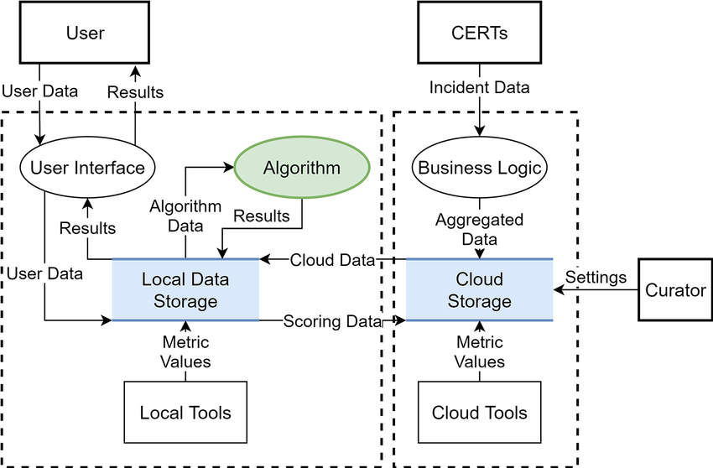
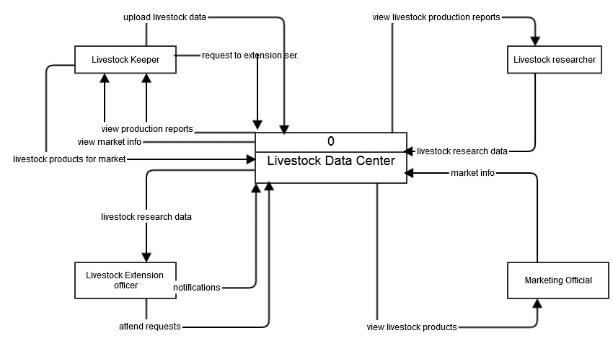
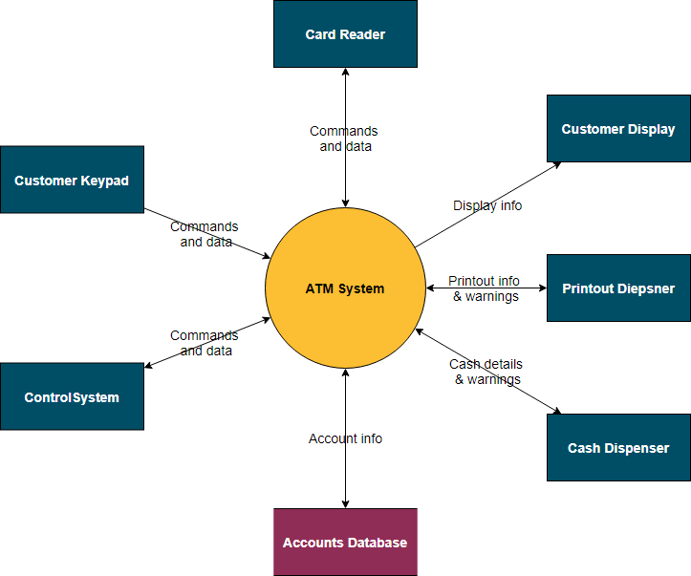
Description
Level 0 shows the whole system as one single process.
External Entities
- User / Student
- Admin
Main Process
- Cyber Threat Awareness & Attack Simulation System
Data Flow
- User → Login Details
- System → Awareness Information / Simulation Results
- Admin → Manage Threat Data / Questions
- System → Reports / Logs
Simple Representation
User --------> Cyber Threat Awareness & Attack Simulation System --------> Awareness Results
Admin --------> (Main System) --------> Reports

2. DFD Level 1
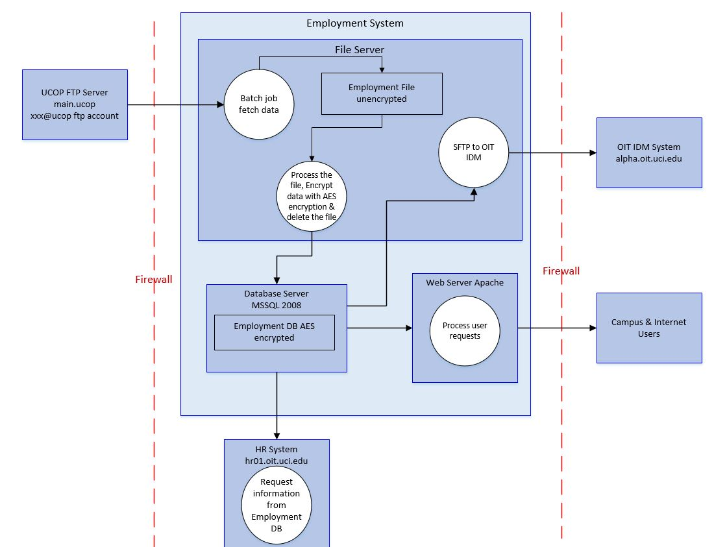
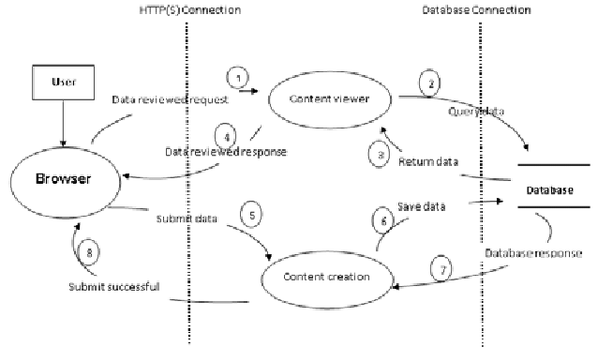

Main Processes
- User Authentication
- Threat Awareness Module
- Attack Simulation Module
- Result & Report Generation
Data Stores
- User Database
- Threat Database
- Simulation Records
Data Flow
User → Login → Authentication
Authentication → User Database
User → Awareness Module → Threat Database
User → Attack Simulation → Simulation Records
Simulation → Result Generation → User

Simple Structure
User
|
User Authentication -----> User Database
|
Threat Awareness Module -----> Threat Database
|
Attack Simulation Module -----> Simulation Records
|
Result & Report Generation
|
User / Admin

3. DFD Level 2 (Attack Simulation Process)

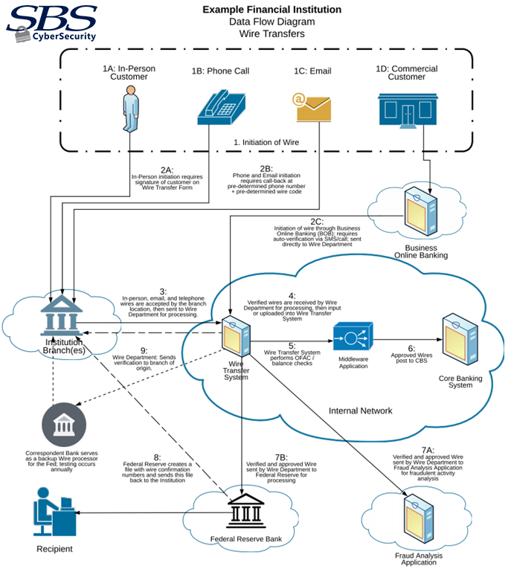
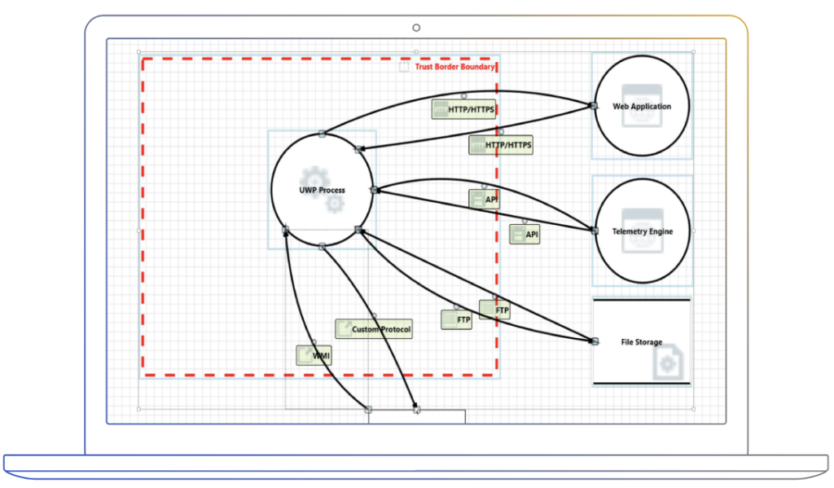
4
Sub Processes
- Select Attack Scenario
- Run Simulation
- Analyze User Response
- Generate Feedback
Data Flow
User → Select Scenario
Scenario → Run Simulation
Simulation → Response Analysis
Analysis → Feedback Generation
Data Store
- Simulation Database
Simple Diagram
User
|
Select Attack Scenario
|
Run Simulation
|
Analyze User Response
|
Generate Feedback
|
Result Stored in Simulation Database

ER Diagram
1. Entities and Attributes
1. User
Attributes:
- User_ID (Primary Key)
- Name
- Email
- Password
- Role (Student/Admin)

2. Admin
Attributes:
- Admin_ID (Primary Key)
- Name
- Email
- Password

3. Cyber Threat
Attributes:
- Threat_ID (Primary Key)
- Threat_Name
- Threat_Type
- Description
- Severity_Level
Examples:
Phishing, Malware, DDoS Attack

4. Attack Simulation
Attributes:
- Simulation_ID (Primary Key)
- Attack_Type
- Simulation_Result
- Date

5. Awareness Module
Attributes:
- Module_ID (Primary Key)
- Topic_Name
- Content
- Difficulty_Level
Examples:
Password Security, Phishing Awareness

6. Report
Attributes:
- Report_ID (Primary Key)
- User_ID
- Simulation_ID
- Score
- Feedback

2. Relationships
- User → Attempts → Attack Simulation
  - One user can attempt many simulations.
- Admin → Manages → Cyber Threat
  - Admin adds or updates threat information.
- Cyber Threat → Used in → Attack Simulation
  - One threat can be used in many simulations.
- User → Studies → Awareness Module
  - Users learn from awareness modules.
- Simulation → Generates → Report
  - Every simulation produces a report.

3. Simple ER Diagram Structure (For PPT Drawing)
You can draw it like this:
USER
(User_ID, Name, Email, Password)
|
| attempts
|
ATTACK SIMULATION
(Simulation_ID, Attack_Type, Result, Date)
|
| based on
|
CYBER THREAT
(Threat_ID, Threat_Name, Type, Severity)
USER
|
| studies
|
AWARENESS MODULE
(Module_ID, Topic, Content)
ATTACK SIMULATION
|
| generates
|
REPORT
(Report_ID, Score, Feedback)
ADMIN
|
| manages
|
CYBER THREAT

PROFILE OF TWO IT COMPANIES
1. Tata Consultancy Services (TCS)
Introduction
Tata Consultancy Services (TCS) is one of the largest IT service companies in the world. It is part of the Tata Group and provides IT services, consulting, and business solutions.
Founded: 1968
Headquarters: Mumbai
CEO: K. Krithivasan
Services Provided
- Cybersecurity solutions
- Cloud computing
- Software development
- IT consulting
- Data analytics
- Digital transformation
Role in Cybersecurity
TCS provides advanced cyber threat detection, risk management, and security consulting services. It helps organizations protect their systems from cyber-attacks such as malware, phishing, and data breaches.
Relevance to the Project
The Cyber Threat Awareness & Attack Simulation System is similar to cybersecurity tools used by companies like TCS to train users and detect vulnerabilities in computer systems.

2. Infosys
Introduction
Infosys is a global leader in technology services and digital consulting. The company helps organizations improve their cybersecurity systems and digital infrastructure.
Founded: 1981
Headquarters: Bengaluru
Founder: N. R. Narayana Murthy
CEO: Salil Parekh
Services Provided
- Cybersecurity services
- Artificial intelligence solutions
- Software development
- IT consulting
- Cloud and infrastructure services
- Digital transformation
Role in Cybersecurity
Infosys provides cybersecurity platforms and threat monitoring systems that help companies detect and prevent cyber-attacks in real time.
Relevance to the Project
Project focuses on cyber threat awareness and attack simulation, which is similar to the security testing and monitoring solutions provided by Infosys to improve system safety.

METHODOLOGY
The Cyber Threat Awareness & Attack Simulation System is developed using the C programming language to help users understand different types of cyber threats and how attacks occur in a simulated environment. The methodology used in this project includes the following steps:
1. Requirement Analysis
In this step, the requirements of the system are identified.
The system should:
- Educate users about common cyber threats.
- Simulate cyber-attacks in a safe environment.
- Provide awareness and prevention techniques.
Hardware and software requirements such as computer system, C compiler, and operating system are also analyzed.
2. System Design
In this phase the structure of the system is designed.
The system is divided into modules such as:
- User Interface Module
- Threat Awareness Module
- Attack Simulation Module
- Result/Feedback Module
Flowcharts and algorithms are prepared to define how data will move through the system.
3. Module Development
Different modules of the system are developed using C programming.
Threat Awareness Module
- Displays information about cyber threats like phishing, malware, and password attacks.
Attack Simulation Module
- Simulates basic cyber-attack scenarios such as weak password attacks or phishing examples.
User Interaction Module
- Allows users to select options and learn about different threats.

4. Implementation
The designed modules are implemented in C language using functions, loops, and conditional statements.
The program runs in a console-based interface where users can select different options to view threats and simulations.
5. Testing
The system is tested to ensure:
- All modules work correctly.
- Simulations run properly.
- User inputs are handled correctly.
Errors and bugs are identified and fixed during this stage.
6. Result and Evaluation
After testing, the system demonstrates different cyber threats and explains how users can prevent them.
The results help users understand cyber security risks and improve their awareness.

FUTURE SCOPE
Cyber Threat Awareness & Attack Simulation System Using C
The current system provides basic knowledge and simulation of cyber threats. In the future, the system can be improved and expanded with more advanced features.
1. Graphical User Interface (GUI)
The system can be upgraded from a console-based program to a GUI-based application to make it more user-friendly and interactive.
2. More Cyber Attack Simulations
Additional cyber-attack simulations such as:
- Phishing attacks
- Malware attacks
- Ransomware attacks
- Network intrusion attacks
can be added to increase learning and awareness.
3. Database Integration
A database can be added to:
- Store user details
- Save user scores or results
- Track learning progress
4. Web-Based System
The project can be converted into a web application so that users can access the cyber threat awareness system from anywhere through the internet.
5. Real-Time Cyber Threat Updates
Future versions can include real-time cyber security news and updates to keep users informed about the latest threats.
6. Advanced Security Training
The system can be expanded to provide interactive cyber security training modules and quizzes for students and organizations.
7. Integration with Cybersecurity Tools
The system can be integrated with tools used in cybersecurity to provide more realistic simulations and learning experiences.

CODE
#include <stdio.h>
#include <string.h>

void phishingAttack()
{
char email[50];

printf("\n--- PHISHING ATTACK SIMULATION ---\n");
printf("You received an email: 'Your bank account is blocked! Click link to verify.'\n");
printf("Do you trust this email? (yes/no): ");
scanf("%s", email);

if(strcmp(email,"yes")==0)
{
printf("\nWARNING! This was a phishing attack.\n");
printf("Never click unknown links.\n");
}
else
{
printf("\nCorrect! You avoided a phishing attack.\n");
}

printf("\nPrevention Tips:\n");
printf("1. Verify sender email.\n");
printf("2. Avoid clicking suspicious links.\n");
printf("3. Use spam filters.\n");
}

void passwordAttack()
{
char password[20];
char realPassword[]="secure123";

printf("\n--- PASSWORD ATTACK SIMULATION ---\n");
printf("Enter system password: ");
scanf("%s",password);

if(strcmp(password,realPassword)==0)
{
printf("\nAccess Granted!\n");
}
else
{
printf("\nAccess Denied! Possible brute force attempt.\n");
}

printf("\nPrevention Tips:\n");
printf("1. Use strong passwords.\n");
printf("2. Enable two-factor authentication.\n");
printf("3. Limit login attempts.\n");
}

void malwareAttack()
{
int choice;

printf("\n--- MALWARE ATTACK SIMULATION ---\n");
printf("You downloaded a free software from an unknown website.\n");
printf("Do you want to install it?\n");
printf("1. Yes\n2. No\n");
printf("Enter choice: ");
scanf("%d",&choice);

if(choice==1)
{
printf("\nSystem infected with malware!\n");
}
else
{
printf("\nGood decision! Malware avoided.\n");
}

printf("\nPrevention Tips:\n");
printf("1. Download software from trusted sources.\n");
printf("2. Use antivirus software.\n");
printf("3. Keep system updated.\n");
}

int main()
{
int option;

while(1)
{
printf("\n===== CYBER THREAT AWARENESS SYSTEM =====\n");
printf("1. Phishing Attack Simulation\n");
printf("2. Password Attack Simulation\n");
printf("3. Malware Attack Simulation\n");
printf("4. Exit\n");

printf("Enter your choice: ");
scanf("%d",&option);

switch(option)
{
case 1:
phishingAttack();
break;

case 2:
passwordAttack();
break;

case 3:
malwareAttack();
break;

case 4:
printf("\nExiting Program...\n");
return 0;

default:
printf("\nInvalid choice!\n");
}
}

return 0;

OUTPUT
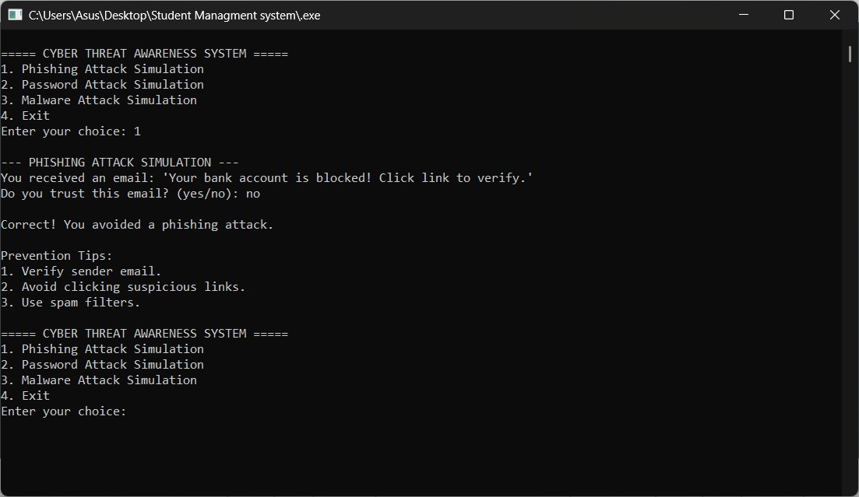

Conclusion
The Cyber Threat Awareness & Attack Simulation System using C helps users understand different types of cyber threats and how they affect computer systems. The project demonstrates basic concepts of cybersecurity by simulating common attacks such as phishing, password attacks, and malware behavior in a controlled environment.
This system improves cybersecurity awareness by showing how attackers exploit vulnerabilities and how users can protect their data and systems. The use of the C programming language makes the system simple, efficient, and suitable for learning fundamental security concepts.
Overall, this project provides a practical approach to learning cyber threats and defensive strategies, helping students and users develop better cybersecurity practices and awareness in the digital world.

BIBLIOGRAPHY
- Behrouz A. Forouzan, Data Communications and Networking, McGraw-Hill Education.
- William Stallings, Network Security Essentials: Applications and Standards, Pearson Education.
- Charles P. Pfleeger and Shari Lawrence Pfleeger, Security in Computing, Prentice Hall.
- Brian W. Kernighan and Dennis M. Ritchie, The C Programming Language, Prentice Hall.
- Official Documentation of GCC – https://gcc.gnu.org
- Cybersecurity learning resources from Cisco Networking Academy – https://www.netacad.com
- Security research articles from OWASP – https://owasp.org

